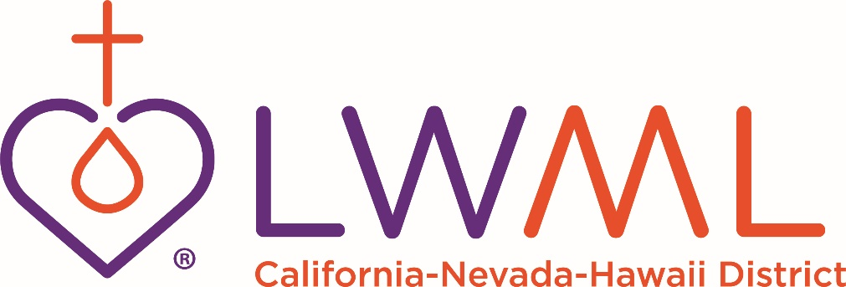
QUARTERLY REMITTANCE FORM
Annual remittance for the LWML Quarterly subscriptions (including increase or decrease in numbers) begins JANUARY 1. All monies must be received by February 15th as the national organization will no longer accept any decrease in numbers after that. Increases in number of subscriptions may be placed at any time. Please return this completed form with your remittance.
Subscription rate for March 2023 – April 2024 is $6.00 each with a minimum of 10 copies. Subscription rate for 1-9 copies is $7.50 each. Individual subscriptions are $7.50 each. If you have any questions, please contact Barbara Guevara at tisbarb@sbcglobal.net.
Please Note: The contact’s name and email information may be used to send future LWML CNH mailings to your society and church.
Zone #
Society Name
Church Name/City/State
Address Quarterly is to be sent to

Contact Name
Contact Email Address
Contact Phone #
Number of Quarterly subscriptions requesting:
Total Remittance: $
Make Checks Payable to: LWML CNH
Mail Form and Check to: Barbara Guevara
PO Box 1522
Millbrae, CA 94030-5522
Quarterly Questions Email: tisbarb@sbcglobal.net

