LWML CNH
2022-24 Mission Grant Posters

#1. VBS for Lord’s Disabled - $3,300
Women in Mission LWML, St. Andrew’s, Stockton, California

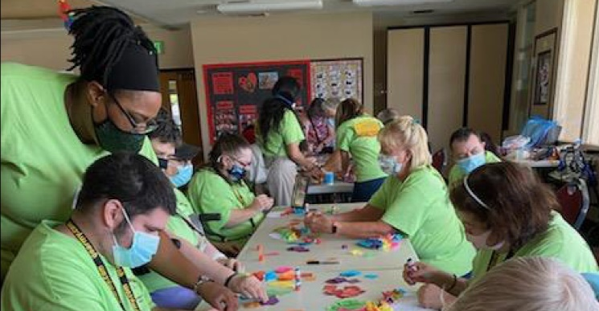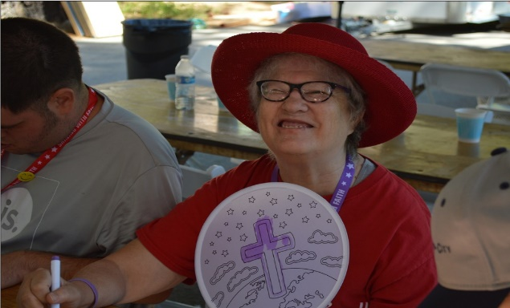

St. Andrew’s of Stockton has had a ministry for the adult mentally and physically handicapped for the last 56 years. In normal times, three Saturdays a month church members welcome the disabled adults for a worship time, a Bible lesson, related crafts, celebrate birthdays, sing Bible songs and share prayer requests. Through this ministry 45 often overlooked children of God have come to know our Lord and been baptized. Due to Covid, the participants were not able to leave their facilities. Grant funds are needed to help provide a customized outdoor VBS program for these mentally/physically challenged adults. The grant provides funds for materials for VBS crafts, Bible study material, snacks and gas for transportation.

#2. Living Water for the Homeless $7,988
Mercy Holistic Ministry & Town and Country Lutheran, Sacramento, California

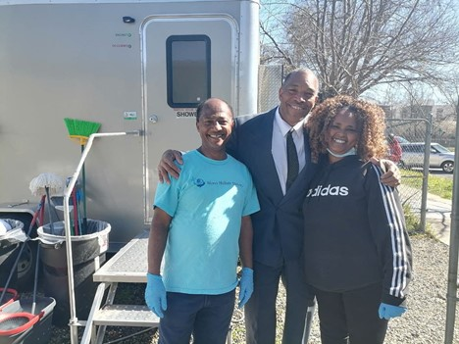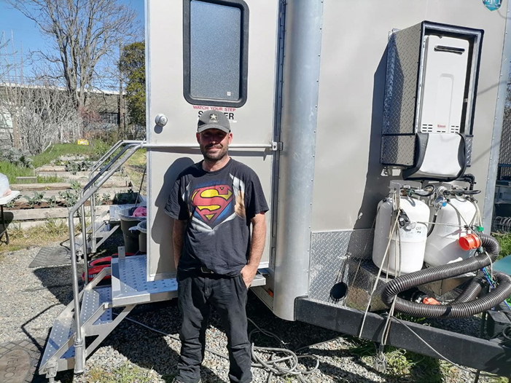

Mercy Holistic Ministry has been working with immigrants in the greater Sacramento area for twelve years by assisting them in transitioning to American society. This ministry, with Pastor Berhanu Kumalo and members of Town and Country Lutheran Church, evolved from monthly feeding and clothing events to a portable shower trailer. The focus is to provide the basic human dignity of being clean in body naturally extends into communicating the need for a clean soul through the love of Jesus. The shower ministry seeks to provide dignity and the love of Christ to the growing homeless population. With each shower the homeless client receives clean underwear and socks, toliettries, a fresh towel and a small Bible. The grant will help pay some of the basic costs of ministry: i.e. truck payments, gasoline, insurance, and related items,
#3. Fort Wayne Seminary Food Co-op - $2,500
Concordia Theological Seminar, Fort Wayne, Indiana

The Co-op is vital to the livelihood of many seminary students, providing 80-85% of the family’s food and household needs at no cost. The seminary seeks to reduce some of the financial burden of the students via the Co-op. This grant is for the purchase of perishable food items and household needs for Seminary students and their families.

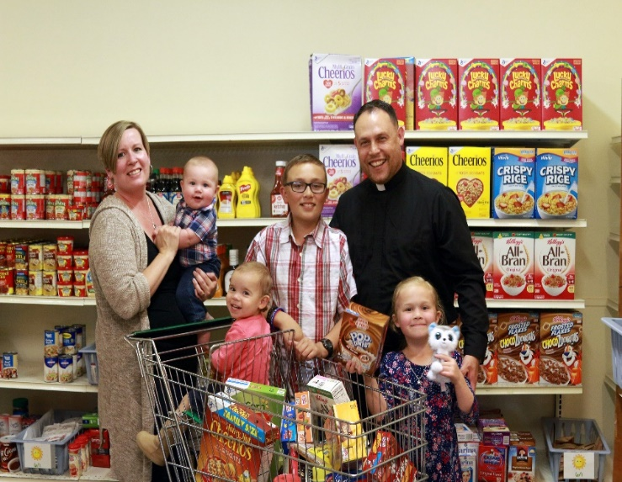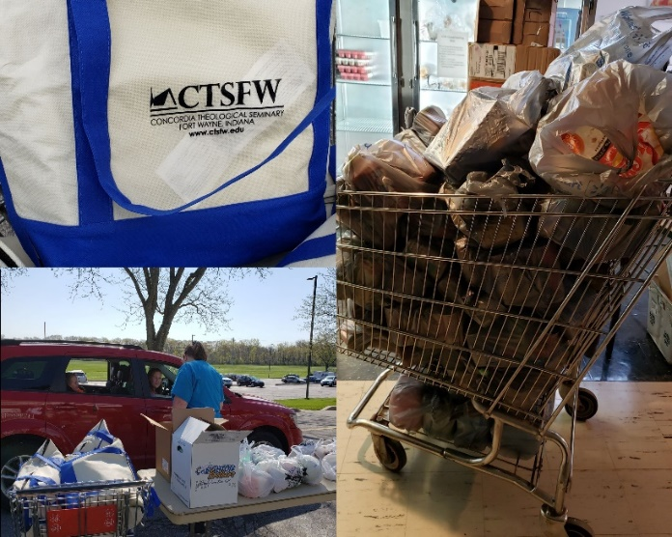

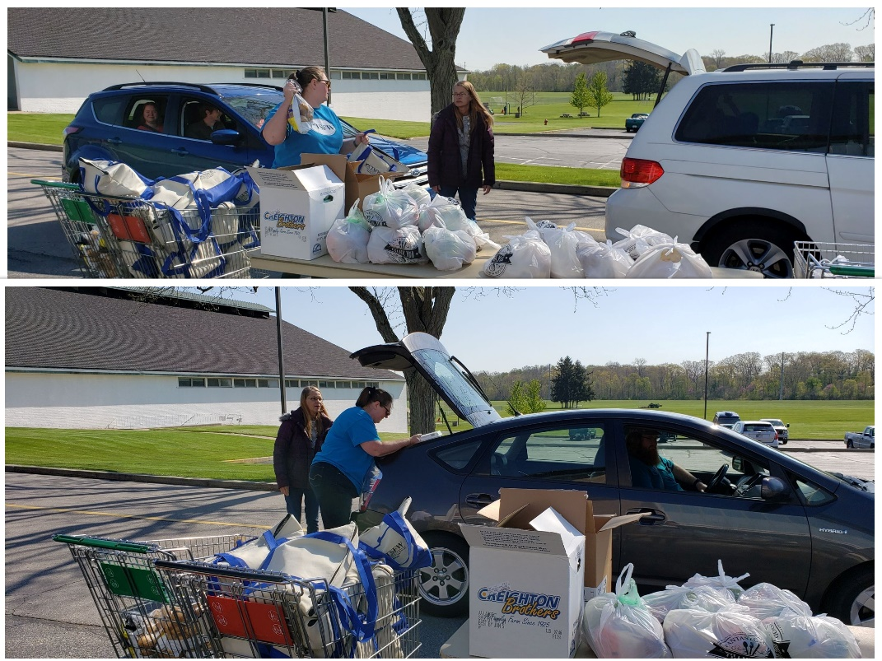

#4. Hmong Lent Family Retreat – $13,000
Redeemer Lutheran, Fresno & St. Paul, Merced, California

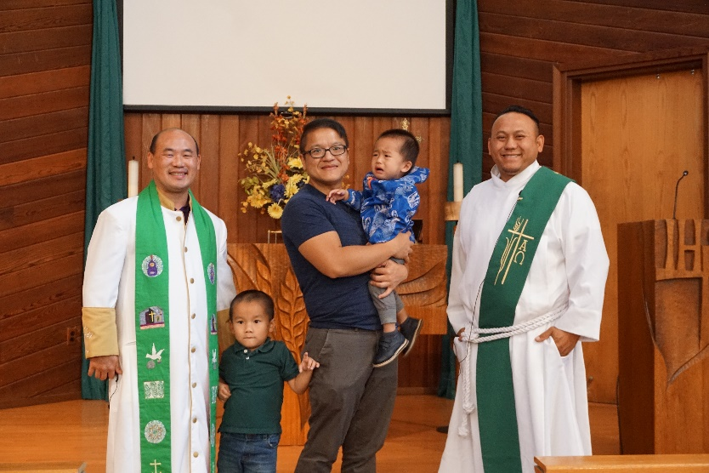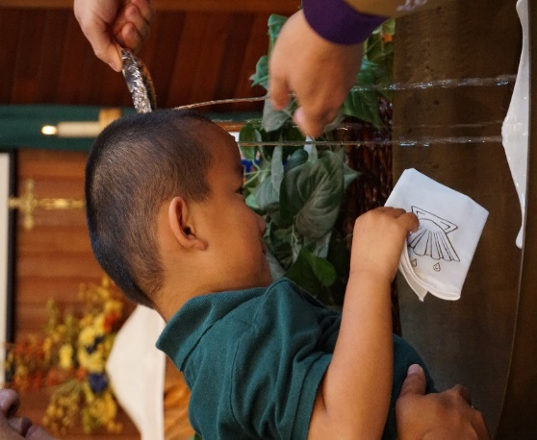

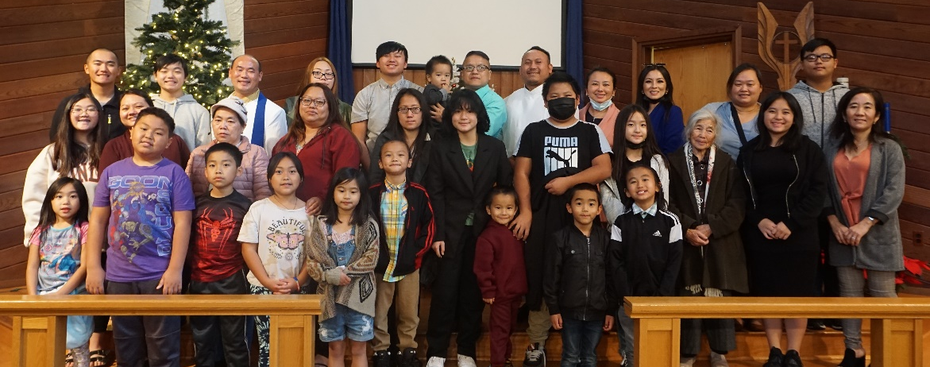

When the Hmong people sought refuge in the USA after the Vietnam war, they brought their cultural tradition of spirit worship with them. They have a strong family unit bonding, often 3 generations live in the same house. The Hmong outreach ministry has been reaching out to the Hmong communities in various ways over the last 6 years. One of the ways has been through the LWML CNH District retreats. Last August 23 Hmong ladies and youth attended the retreat. The benefits of the retreats is reaching both the churched and unchurched with knowledge of Jesus. The Hmong Outreach ministry would like to have a Lenten family retreat for an in-depth program Maundy Thursday through Easter Sunday. Hmong families will get a chance to know Jesus better through the lens of the Lenent Season. They will learn Jesus’s journey and purpose of traveling to Jerusalem to die for the world s well as His resurrection at that First Easter. Non-believers, often family members will hear testimonies in their native language of how Jesus has blessed them in their daily lives since becoming believers. The funds will be used to offset the cost of the retreat facilities, Lenten devotionals and pamphlets.

#5. Outreach Ministry to Homeless - $8,000
Bridging Initiatives International and Town and Country Lutheran, Sacramento, California

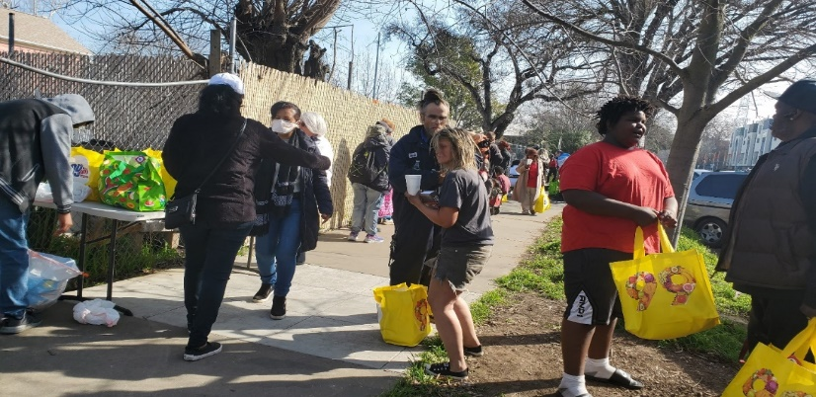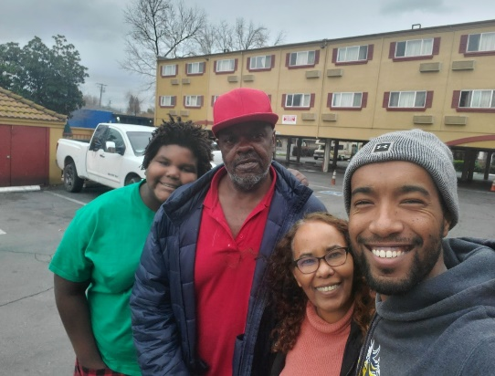
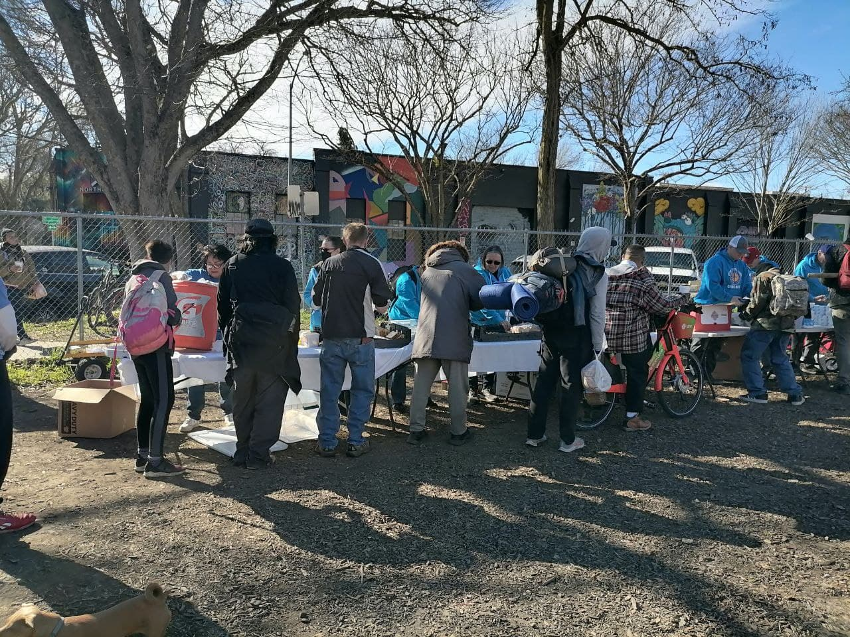

This ministry partners with Mercy Holistic Ministry’s shower outreach by providing counseling (mental health, rehab) and connecting with other services for the homeless (shelters and housing). After the shower session each individual is seen by a caring individual working with Bridging Initiatives. During theses one-on-one sessions the life-changing gospel of Jesus is shared. The grant funds are for: brochures, transportation, gift cards, temporary motel vouchers, educational materials, food, blankets, and clothes.

#6. Music Ministry and Healing for At-Risk Children $2,072
Dakota Boys and Girls Ranch, Minot, North Dakota

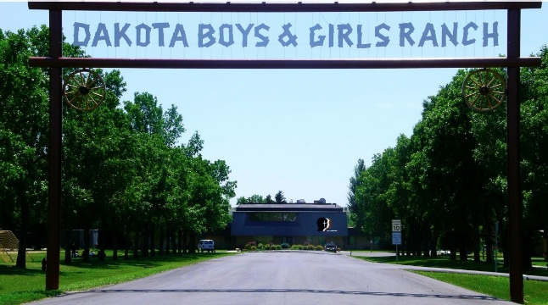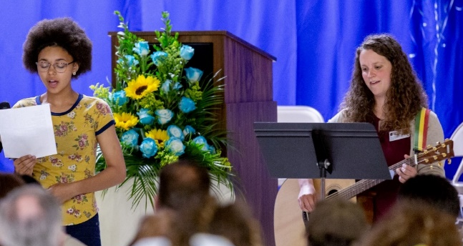

Since 1952 Dakota Boys and Girls Ranch has positively impacted the lives of more than 37,000 at-risk children and their families. The Ranch brings Christ-centered hope and healing to children who have experienced severe psychiatric, emotional, behavioral, and/or developmental challenges due to abuse, neglect, violence. The Ranch has an effective Music Ministry as part of its therapeutic healing. The grant seeks funds to expand the music ministry by purchasing additional instruments and music stands.
#7. Walking with Women Leaders $18,050
LINC Bay Area, Hayward, California

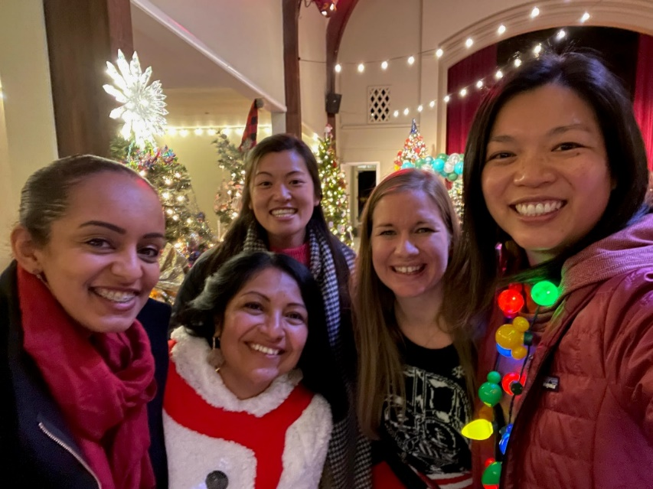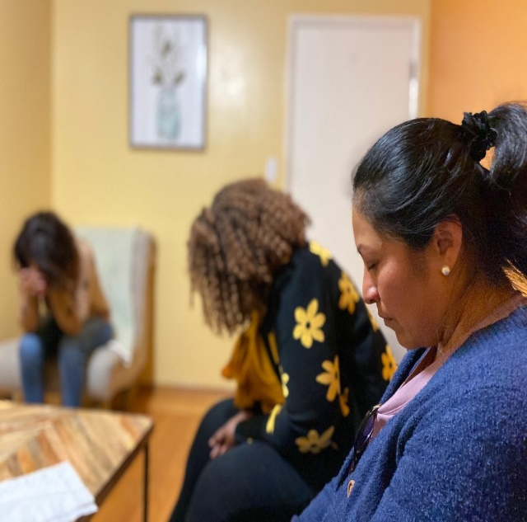

LINC plays an integral role in raising up local leaders to serve LCMS members and congregations. LINC is partnering with LCMS CNH District Bay area churches to develop leaders in the cross-culture communities for the ministry. LINC is implementing a new program, focusing on Women Leaders. LINC realizes that women are vital in the community and family, especially in our churches. Thus, LINC wants to ensure women are provided the needed support via coaching, training in discipleship and funding theological training to women, in this multi-cultural ministry. This grant will cover expenses for identifying, developing, training, coaching and some theological scholarships for 10 Bay area Women. This grant emphasizing the role of women in sharing the gospel of Christ.

#8. International Seminary Students-St. Louis - $10,000
Concordia Seminary, St. Louis, Missouri

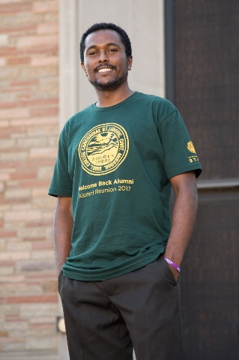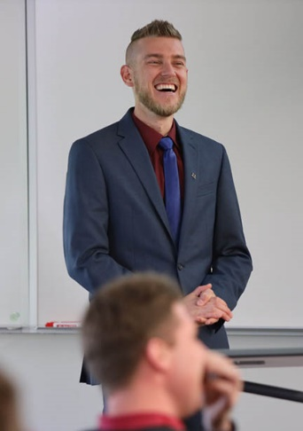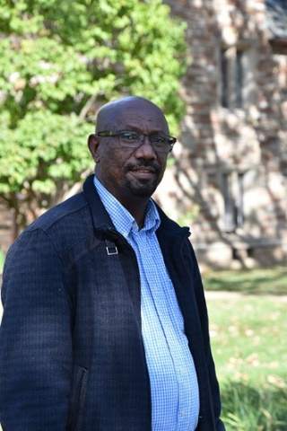
There is a significant shortage of well-formed Lutheran pastors in some parts of the world because options are few for advanced theological study for these pastors and few overseas Lutheran church bodies have the resources to send their most capable students to the US for this advanced study. Concordia Seminary, St. Louis currently has 50 international students from 25 different countries. After graduation the students will serve as seminary professors, theological instructors and church leaders in their respective countries. The estimated number of lives that these students/pastors/professors will impact in their home countries could be in the many thousands. A wide variety of cultures and ethnicities in many nations will be impacted, including a significant number of unchurched people. The grant funds will help provide vital support for Concordia Seminary’s international students.
#9. Be Thou My Vision- Eyeglass and Evangelism - $6,000
MOST Ministries, (Mission Opportunities Short Term), Ann Arbor, Michigan

Who can care for their family, complete tasks for work, school, drive at night, or read your Bible without glasses? Vision is the most dominant of our senses and is vital in virtually every aspect of our lives. Eyeglass and Evangelism ministry has become one of MOST’s most sought after services. MOST Ministries serves nearly 10,000 people each year through eyeglass clinics. MOST Ministry teams pack, ship and carry over 30,000 pairs of recycled eyeglasses around the world annually. The grant is seeking funds to continue supplying eyeglass and evangelism teams with reused, recycled and upgraded eyeglasses.

#10. Spanish Braille Bibles, So. America $3,500
Zone 8 and Lutheran Braille Workers

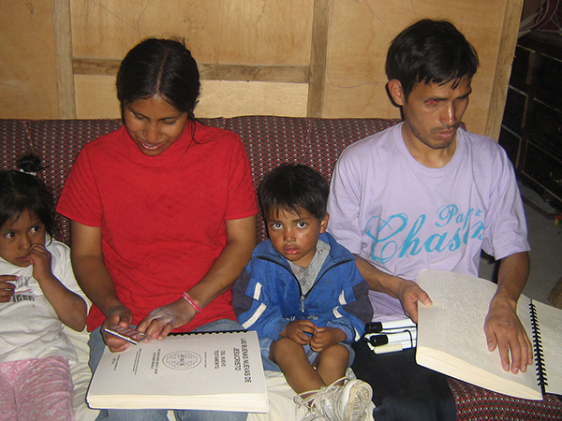

The mission of Lutheran Braille Workers is to provide the message of salvation to people who are blind or visually impaired. It is impossible to reach people in other countries without the Word of God in their language. Recently, LBW was approached by the United Bible Society with an order for 1,000 complete Braille Bibles in Spanish. The Argentine Bible Society asked for 500 from the order. The grant is to fund the purchase of resources and materials to produce Spanish Braille Bible for free distribution, primarily to the Bible Societies in South and Central America over the next two years.
#11. CNH District Cross Cultural Outreach Training $2,500
POBLO International

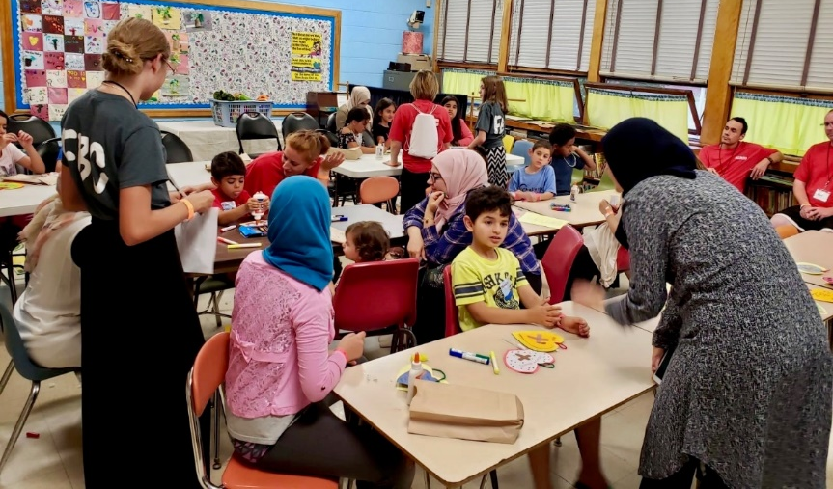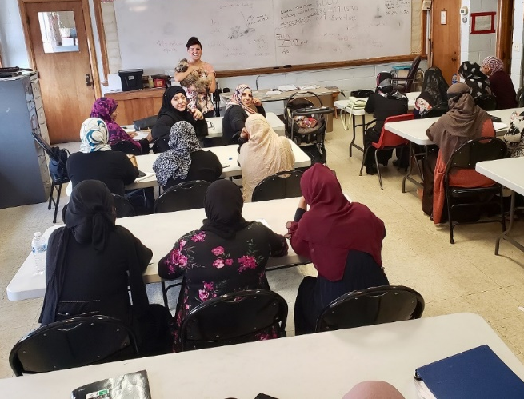

An increasing number of immigrants and refugees are coming to the USA, particularly to CNH District. Many Americans, and churches do not know how to interact with, or respond to these various cultures. POBLO International wishes to provide Cross Cultural Outreach Training to all the churches in CNH District. The training will provide a gateway for the churches to learn how to effectively engage with and form meaningful relationships with the unchurched people from other cultures. POBLO requested funds for this grant to provide in-person and virtual cross cultural outreach training.

#12. Spanish Devotions - $7,500
Lutheran Heritage Foundation

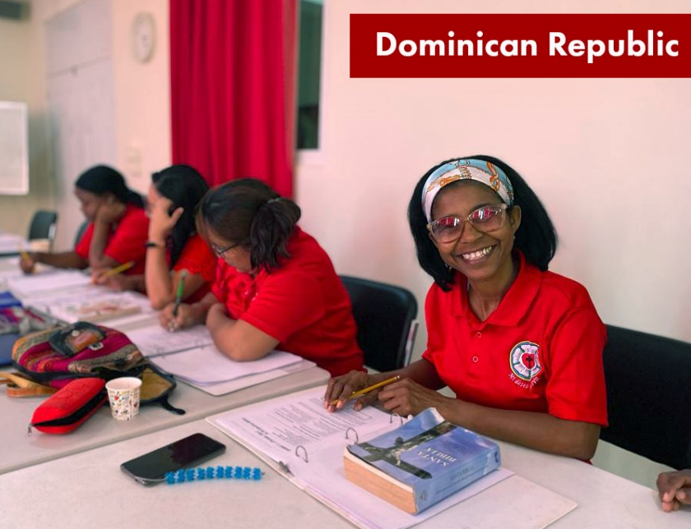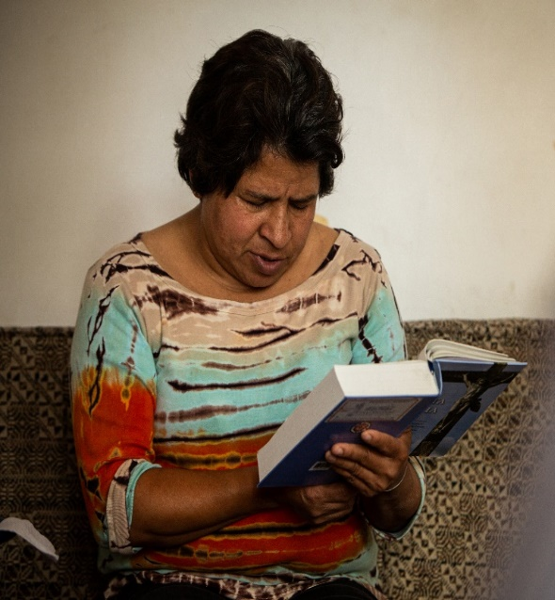
More than 475 million people in 20 countries worldwide speak Spanish as a first language, including millions in CNH District. According to recent census statistics, over 30,000 Hawaiians, and 625,000 Nevadans speak Spanish. In California the number skyrockets to over 10.7 million, more than 25% of the total populations. Unfortunately, daily devotions in the Spanish language are difficult to come by. A publishing house ceased their production of Spanish translation. As a result there are no Confessional Lutheran daily devotions in Spanish. This grant proposal is for funds for Lutheran Heritage Foundation to write, edit, print and convert to digital format for e-readers daily devotions in Spanish for Lutherans throughout the world may walk daily with Jesus. The devotions are given free to churches, ministries and families.
#13. Hope for the Hopeless - $5,000
LCMS Mission Advancement

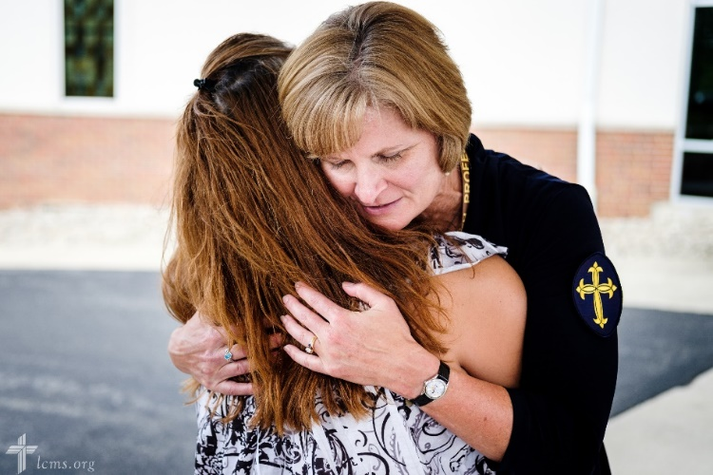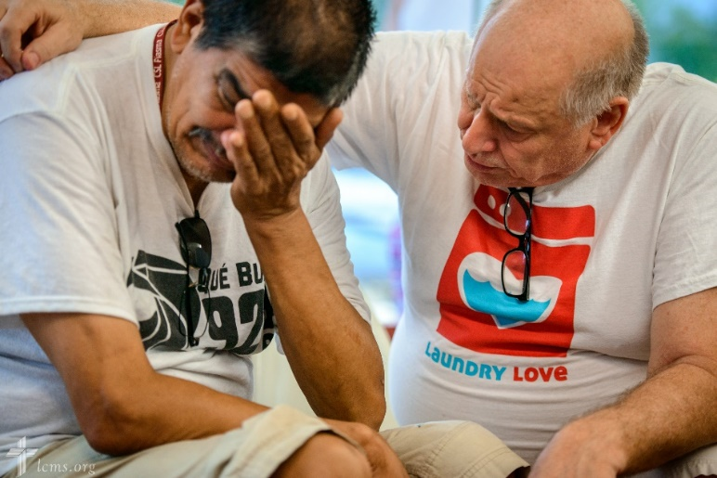

The Lutheran Church-Missouri Synod (LCMS) Life Ministry network is comprised of thousands of people throughout the LCMS who are passionate about and engaged in sanctity of human life efforts, both in our church body and the culture at large. All human life is valued from conception to natural death. Suicides are a growing issue in our society to which the church needs to respond. Life Ministry is developing distinctly Lutheran training to equip pastors, church workers and lay leaders with resources for interventions to share the hope that is found in Christ through Christian love and care in psychologically appropriate ways in order to prevent suicide from occurring. The funds requested are part of this project to develop curriculum, produce the resources, websites, videos and brochures.

#14. Connecting Mercy & Church Planting – Latin America - $5,000
LCMS Office of International Mission, Latin America and the Caribbean Region

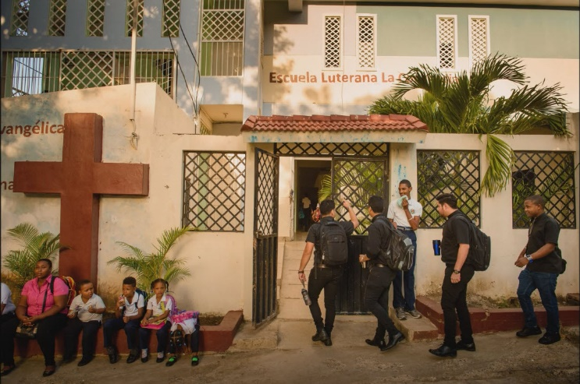

The Latin America and Caribbean region of the Lutheran Church-Missouri Synod (LCMS) is blessed to have Concordia the Reformer Seminary in the Dominican Republic. The seminary is serving 47 Seminary students (residential and on-line) in 12 countries throughout the region. The Seminary’s Deaconess Formation program serves 140 women in 5 countries. The seminary invests in the practical formation of pastors and deaconesses by supplementing classroom learning with hands-on field work. This grant requests funds to help provide scholarships for students attending the seminary in person and on-line.

#15. Matongo Seminary Chapel - $5,000
LCMS Office of International Mission, Africa Region

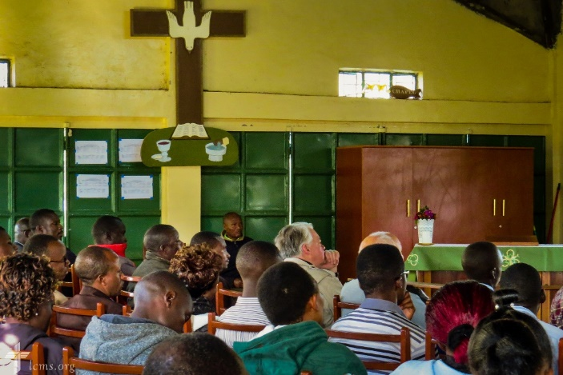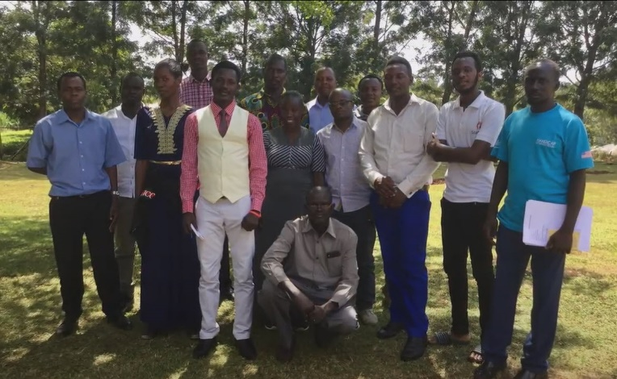

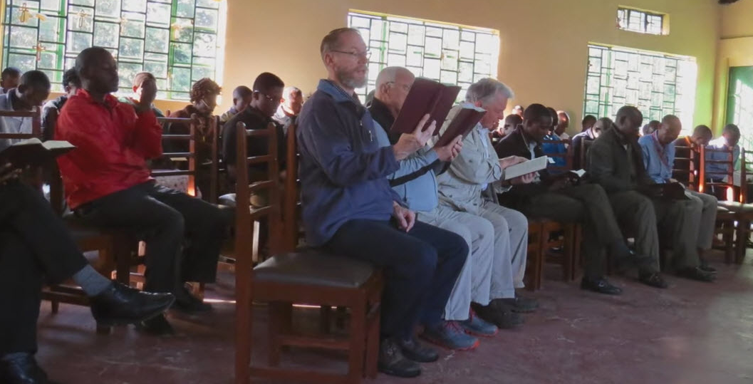

The Lutheran Church-Missouri Synod (LCMS) has a long-standing relationship with the Evangelical Lutheran Church in Kenya (ELCK) and are together in Altar and Pulpit Fellowship. Matongo Lutheran Seminary, Located in Kenya, is a conservative confessional Lutheran college and provides a variety of credentials to students from a Certificate in Deaconess Studies to a Bachelor’s Degree in Theology for pastoral candidates. Students come from across the greater Eastern Africa area. Matongo Lutheran Seminary is the only institution recognized by the ELCK for training of pastors, deaconesses and evangelists for its congregations. The center for spiritual life for a seminary is its chapel; essential for the campus community for daily worship, encouragements and strengthening for spiritual formation. Currently the seminary is using a multi-purpose room for daily worship services in Kishwahili and English. The grant is seeking funds to help build a proper chapel at the seminary.

#16. Gospel Outreach in Thailand $3,500
Lutheran Hour Ministries

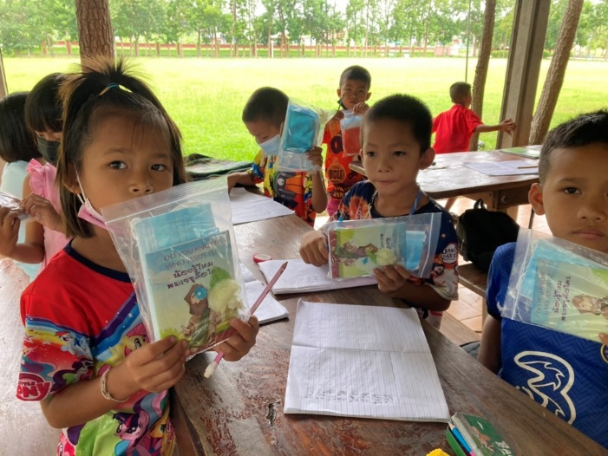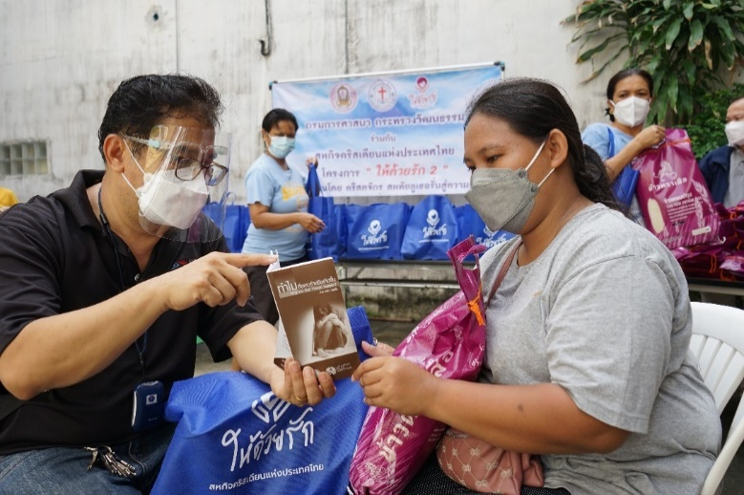

Lutheran Hour Ministries (LHM) sees a tremendous opportunity to share God’s love reaching out with the Gospel to the people of Thailand. LHM-Thailand’s work is rapidly expanding to all area of the country. Most of the population is non-Christian. LHM in Thailand has a variety of outreaches: radio programming, digital and social media, Bible correspondence courses, evangelism training seminars and special events. All these programs are done in the native language of Thailand as well as culturally appropriate ways for the various regions. The grant funds would be used for all the above outreach programs.

#17. Indonesian Hymnal Project - $5,000
LCMS Office of International Mission, Asia Region

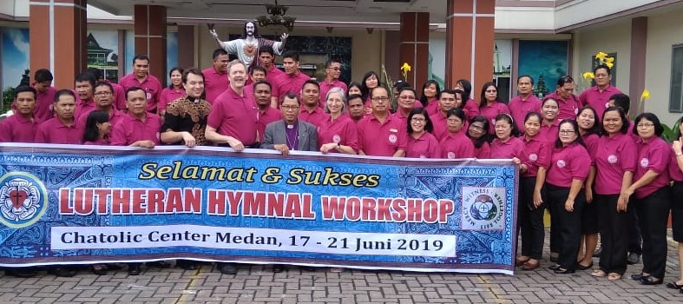

The Lutheran Church-Missouri Synod (LCMS) Office of International Mission and the Indonesian Christian Lutheran Church (GKLI) have been coordinating on the development of an explicitly Lutheran service book in Indonesian since October 2017. To date there is no quality service book available in Indonesian, let alone a quality Lutheran service book. The Indonesian Hymnal Project will open rich musical heritage in liturgy and hymns to all Indonesians; train congregations to think, sing, and speak theologically in Indonesian native tongue while strengthening their Gospel Proclamation in their communities, and be a vial tool for parents/grandparents to pass down the faith to their children and grandchildren. Funds from this grant help in publishing the Indonesian Hymnal.

