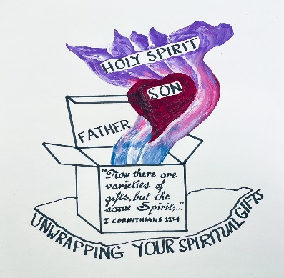
The LWML’S GOT TALENT!!
Let’s celebrate our uniqueness and abilities in a fun way! Share your simple (or not so simple) talent (or something you enjoy doing) at the CNH LWML RETREAT TALENT SHOW!

Types of skills could include: Musical, Physical, Artistic, Humorous, Dramatic, Instructive, or your own idea.

GUIDELINES: 2–5-minute time-limit for each act. Both single and small group performances are encouraged. There will be no judging because we are all winners in Christ!

Sign up on your registration form if you would like to participate in the
LWML’S GOT TALENT SHOW
Questions? Need ideas?
Call Judy Huber at
209 (602-8560) email: pinegrovejudy@gmail.com

