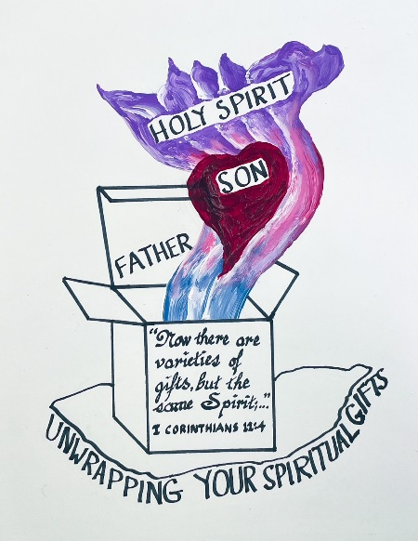

LWML CNH RETREAT
August 25-27, 2023
Registration – Friday 4 pm; Checkout – Sunday 11:30 am
Episcopal Conference Center Oakhurst (ECCO)
43803 Highway 41, Oakhurst, CA 93644
559 683 8152

S C H E D U L E

FRIDAY
4:00 pm Lobby – Registration (Main Office Building/Dining Hall)
check-in, mingle and find your prayer partner
6:00 pm Dining Room – Dinner
7:00 pm Chapel – Music / Overview / Speaker
9:00 pm Outdoor Chapel – Evening Devotions (bring flashlights)

SATURDAY
7:00 am Outdoor Chapel – Morning Devotions
Prayer Walk – Walking Trails
8:00 am Dining Room – Breakfast
9:00 am Chapel – Singing / Bible Study
12:00 pm Dining Room – Lunch
1:00 pm Chapel – Singing / Bible Study
2:45 pm Break-out Groups (various locations)
4:00 pm Free Time
      - Prayer Walk, Nap, Fellowship
      - LLWest Room –Service Project – Lutheran Braille Workers
      - Dining Room – Service Project – Phil’s Friends
6:00 pm Dining Room – Dinner
7:00 pm Chapel – Talent Show
LLWest Room – Service Project – Lutheran Braille Workers

9:00 pm Outdoor Chapel – Evening Devotions (bring flashlights)

SUNDAY
7:00 am Outdoor Chapel – Morning Devotions
Prayer Walk – Walking Tails
8:00 am Dining Room – Breakfast --- CHECK OUT OF ROOMS
9:30 am Chapel – Worship/Communion

