ALL WOMEN ARE INVITED TO THE LWML CNH CONVENTION
June 10-12, 2022
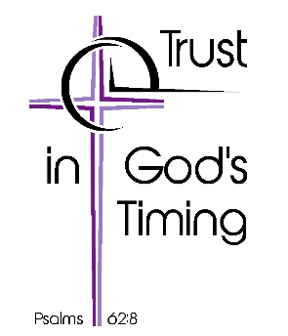
Nugget Casino Resort, Sparks, NV
Convention Theme: TRUST IN GOD’S TIMING
Convention Bible Verse:
Psalms 62:8 RSV: “Trust in him at all times, O people; pour out your heart before him; God is a refuge for us.”

- Bible Study Leader: Michelle Ule
- Inspiration Speaker: Beth Zier
- Music Leader: Brittany Brown
- 8 Breakout Sessions
- Ingathering
- Service Events
- SWAP – Study, Worship And Prayer
Great Venue:
Large Convention Center all on one floor
Reasonable Room Rates – 4 to a room - $119.00 plus $15.00 resort fee
Family Friendly Area

