Rev. 11/12/17 Mites/Scholarship/Memorial/Endowment Funds
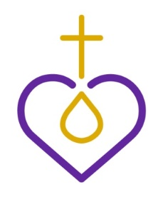
Lutheran Women’s Missionary League California-Nevada-Hawaii District

REMITTANCE FORM for MITES
and SCHOLARSHIP/ MEMORIAL/ ENDOWMENT FUNDS

DATE: ZONE NO: _

Name of Society: Name of Church: Address of Church:
Church Email: Sender’s Name: Sender’s Address: Sender’s Email Address and Phone No:
MITES: $

RUBIN PERPETUAL SCHOLARSHIP FUND: $

STEINBECK MEMORIAL SCHOLARSHIP FUND: $

MEMORIAL FUNDS: $ ** LWML CNH ENDOWMENT FUND: $ **
OTHER: $ PLEASE SPECIFY

**We donate these funds in the name of:

MAKE CHECKS PAYABLE TO: LWML

SEND REMITTANCE FORM & CHECK(S) TO DISTRICT FINANCIAL SECRETARY

Kathy Richardson
236 W. East Ave., Ste A, PMB #199
Chico, CA 95926
530-680-2322 or Email: calsgirlkathy@gmail.com

MAKE COPIES OF THIS FORM AS NEEDED. SEND ONE COPY WITH YOUR REMITTANCE

