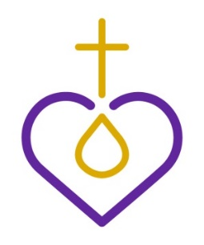
Lutheran Women’s Missionary League California-Nevada-Hawaii District

QUARTERLY REMITTANCE FORM

Annual remittance for the LMWL Quarterly subscriptions (including increase or decrease in numbers) begins JANUARY 1. All monies must be received by February 15th as the national organization will no longer accept any decrease in numbers after that. Increases in number of subscriptions may be placed at any time. Please return this completed form with your remittance.

Subscription rate for March 2020 – April 2021 is $6.00 each with a minimum of 10. Subscription rate for 1-9 copies is $7.50 each. Individual subscriptions are $7.50 each. If you have any questions, please contact Christa Hamilton at cafudge@sbcglobal.net or phone at 805-610-9599.

Please Note – The contact name and email information may be used to send future LWML CNH mailings to your society and church.

-------------------------------------------------------------------------------------------------------------------

Society Name: Zone #

Name of Church/City, State:

Address Quarterly is to be sent to:

Contact Name:

Contact email Address:

Contact Phone Number:

Number of Quarterly subscriptions requesting:

Total Remittance Make checks payable to: LWML
Mail form and check to: Christa Hamilton, Financial Secretary
P. O. Box 787,Atascadero CA 93423
805-610-9599 or Email: cafudge@sbcglobal.net

